

**AI BASED DISCOURSE FOR BANKING INDUSTRY**

**A PROJECT REPORT**

***Submitted by***

**ASWIN SATHEESH (721819104002)**

**LIJU KRISHNA (721819104010)**

**SHINU S (721819104024)**

**SREEJITH KS (721819104028)**

***in the partial fulfilment of the requirements for the award of a degree***

***of***

**BACHELOR OF ENGINEERING**

**IN**

COMPUTER SCIENCE AND ENGINEERING

**RATHINAM TECHNICAL CAMPUS, COIMBATORE.**

**ANNA UNIVERSITY: CHENNAI 600 025**

NOVEMBER & 2022

Project Report Format

# INTRODUCTION

* 1. Project Overview
  2. Purpose

# LITERATURE SURVEY

* 1. Existing problem
  2. References
  3. Problem Statement Definition

# IDEATION & PROPOSED SOLUTION

* 1. Empathy Map Canvas
  2. Ideation & Brainstorming
  3. Proposed Solution
  4. Problem Solution fit

# REQUIREMENT ANALYSIS

* 1. Functional requirement
  2. Non-Functional requirements

# PROJECT DESIGN

* 1. Data Flow Diagrams
  2. Solution & Technical Architecture
  3. User Stories

# PROJECT PLANNING & SCHEDULING

* 1. Sprint Planning & Estimation
  2. Sprint Delivery Schedule
  3. Reports from JIRA

# CODING & SOLUTIONING (Explain the features added in the project along with code)

* 1. Feature 1
  2. Feature 2
  3. Database Schema (if Applicable)

# TESTING

* 1. Test Cases
  2. User Acceptance Testing

# RESULTS

* 1. Performance Metrics

# ADVANTAGES & DISADVANTAGES

1. **CONCLUSION**

# FUTURE SCOPE

1. **APPENDIX**

Source Code

GitHub & Project Demo Link

**1.INTRODUCTION**

Artificial intelligence (AI) chatbots are a fascinating advancement in today’s digital technology landscape. They can do it all whether it’s helping you create a bank account, answering specific questions, or guiding you through a complex process.

AI chatbots for banking helps a customer to create bank accounts and answers the questions quickly about loans and general banking.

Chatbots process the data provided by the site visitor to generate the right response. They help answer questions and offer next steps, such as scheduling a demo, loan, deposit or withdraw. Best of all, they’re active 24/7, whether the teams of banking is online or not.

**1.1 Project overview:**

In this project, we will be building a chatbot using Watson's assistant. This chat should have the following capabilities:

* The Bot should be able to guide a customer to create a bank account.
* The Bot should be able to answer loan queries.
* The Bot should be able to answer general banking queries.
* The Bot should be able to answer queries regarding net banking.

**1.2 Purpose**:

Chatbots are designed to give people an automated way to communicate with your company. They may answer basic questions, make product recommendations, and provide customer support designed to allow humans and computers to connect in a natural way. Over the last few years, these technologies have become more intelligent, and they have become one of the most potent tools for getting things done in a modern office setting. Chatbots increase operational efficiency by automating customer service. In banking, they can improve the omnichannel customer experience by reducing response times and allowing customers to get their queries resolved quickly. Chatbots enable users to make quick, painless payments in a matter of seconds while maintaining the highest level of security and data protection. Conversational banking chatbots make the payment process faster, safer, and more secure.

**2.LITERATURE SURVEY**

**Domain Name**: Banking and Finance

**Use case Name:** AI based discourse for Banking Industry

**Paper-1**

**Title**: Chatbots in Banking Industry: A Case Study

**Author**: Dr. Shalini Sayiwal

**Published year**: 2020

**Description:** The about paper states regarding the banking industry and the technology has provided several unique ways to enable the sector to maximize consumer happiness. Introducing chatbots to its clients is one such clever tactic. One of a bank's most promising business techniques that can help it win the loyalty of its devoted consumers is the use of chatbots created using AI. This paper examines about the pros and cons of the existing Chatbots names EVA (Electronic Virtual Assistant) of HDFC (Housing Development Finance Corporation Limited) and Keya of Kotak Mahindra Bank

**Paper – 2**

**Title:** An Ontology-Based Dialogue Management System for Banking and Finance Dialogue Systems

**Author**: Duygu Altinok

**Description:** Keeping the dialogue state in dialogue systems is a notoriously difficult task. So this paper introduce an ontology-based dialogue manager (OntoDM). With this new framework the author addresses the dialog management. It describes domain-driven ways to keep the conversation memory. the user and the bot side, make the anaphora resolution, generate knowledge based answers, possibly contribute to what to say next, integrate linguistic features into the context NLU but answer generation modules were considered in detail in this paper.

**Paper - 3**

**Title:** Conversation to Automation in Banking Through Chatbot Using Artificial Machine Intelligence Language

**Author:** Sasha Fathima Suhel, Vinod Kumar Shukla, Sonali Vyas and Ved Prakash Mishra

**Published yea**r: 2020

**Description**: The paper demonstrates how AI is always evolving. This study introduces a novel idea that discusses machine intelligence and highlights the possibilities of intelligent systems. The latest disruptive force that has altered how customers connect is the growth of chatbots in the finance industry. Artificial intelligence has transformed the way that banks communicate with their consumers in the banking sector by enabling chatbots. Any nation's development depends heavily on the banking industry. It also investigates the chatbot's current usability to determine whether it can satisfy customers' fluctuating needs.

**Paper – 4**

**Title**: Text-Based Chatbot in Financial Sector: A Systematic Literature Review

**Author:** Hana Demma Wube, Sintayehu Zekarias Esubalew, Firesew Fayiso Weldesellasie and TayeGirma Debelee

**Published year:** 2022

**Description:** This study gives a thorough, systematic analysis of the literature of papers on text-based chatbots in the banking industry. It discusses the understanding of chatbots in the financial sector in terms of implementation, adoption intention, attitude toward use, and acceptance; it also discusses how people perceive, expect, and trust chatbots, as well as how they are engaging and emotionally motivated; management of the security and privacy vulnerabilities of the chatbots; and it identifies potential strategies that can impede the effective, successful use of chatbots. Finally, the key findings on the use of text chatbots in the financial industry are given. In addition, the unresolved problems in the existing study are noted, and a number of future research avenues are recommended.

**Paper – 5**

**Title**: A Review of Chatbots in the Banking Sector

**Author:** Shashank Bairy R and Rashmi R

**Published year:** 2021

Description: This paper explains the basic anatomy of the chatbots and the various applications of the chatbots in banking sector. It also went over various improvements that could be made on the current chatbot technologies. It states that the role of chatbots play in the banking sector will only continue to raise due to the constant improvements being made to its logic and increased demand among the customer for better experience

**2.1 EXISTING PROBLEM**

* A machine learning system needs people to gather, pick, and clean every single piece of training data since it takes an incredible quantity of data to utilize machine learning to understand humans**.**
* Organizations must assist their clients in a variety of languages, a problem that will only get worse over time. As a result, chatbots must be multilingual and have the capacity to learn new languages as necessary**.**
* Humans can make sure that questions with the same meaning receive the same answer in a conversational system based on language. Even within the same conversation, a machine learning system might not be able to correctly identify queries that are similar but are stated differently.
* Most chatbot development technology requires a great deal of effort and often complete rebuilds for each new language and channel that needs to be supported, leading to multiple disparate, solutions all clumsily co-existing.
* Despite the fact that producing enormous amounts of data opens up more business prospects, doing so simultaneously raises storage and security concerns. The likelihood of data leak into the hands of someone on the dark web increases as more data is created and as more individuals gain access

**2.2 REFERENCES**

1. "CHATBOTS IN BANKING INDUSTRY: A CASE STUDY", International Journal of Emerging Technologies and Innovative Research (www.jetir.org | UGC and issn Approved), ISSN:2349-5162, Vol.7, Issue 6, page no. pp1498-1502, June-2020, Available at : <http://www.jetir.org/papers/JETIR2006221.pdf>
2. Shashank Bairy R , Rashmi R, 2021, A Review of Chatbots in the Banking Sector, INTERNATIONAL JOURNAL OF ENGINEERING RESEARCH & TECHNOLOGY (IJERT) Volume 10, Issue 06 (June 2021), Available at : <https://www.ijert.org/a-review-of-chatbots-in-the-banking-sector>
3. 9 pages, 27 figures, goes to 1st Financial Narrative Processing Workshop @ LREC 7-12 May 2018, Miyazaki, Japan ,Subjects: Computation and Language (cs.CL), Cite as:arXiv:1804.04838 [cs.CL] (or arXiv:1804.04838v1 [cs.CL] for this version)

<https://doi.org/10.48550/arXiv.1804.04838>

1. @article{Suhel2020ConversationTA,title={Conversation to Automation in Banking Through Chatbot Using Artificial Machine Intelligence Language},author={Sasha Fathima Suhel and Vinod Kumar Shukla and Sonali Vyas and Ved Prakash Mishra},journal={2020 8th International Conference on Reliability, Infocom Technologies and Optimization (Trends and Future Directions) (ICRITO)},year={2020},pages={611-618}}<https://www.semanticscholar.org/paper/Conversation-to-Automation-in-Banking-Through-Using-Suhel-Shukla/53b6fc81e387fdbc0951bc10de0a62a798bf120e>
2. Hana Demma Wube, Sintayehu Zekarias Esubalew, Firesew Fayiso Weldesellasie, Taye Girma Debelee. Text-Based Chatbot in Financial Sector: A Systematic Literature Review[J]. Data Science in Finance and Economics, 2022, 2(3): 232-259. doi: 10.3934/DSFE.2022011

<https://www.aimspress.com/article/id/62e77066ba35de346154fa4c>

**2.3 PROBLEM STATEMENT DEFINITION**

Banking is an important industry since it deals with financial transactions that anyone may use, yet banks are frequently unable to satisfactorily respond to client questions about their goods or services, which lowers customer satisfaction. To give customers the best choice, an intelligent system must be put in place to guide them through all of the financial services the bank provides. The users are bank customers who need a service that is always on call to respond to all of their enquiries and guide them through the various banking processes. To ensure effective service delivery, a better and more intelligent manner of communication with clients must be created. It is meant to act as the all-inclusive virtual assistant that enables customers to make appropriate recommendations and ask banking related questions without having to visit a bank or phone customer service centers.

**Problem statement 1:**

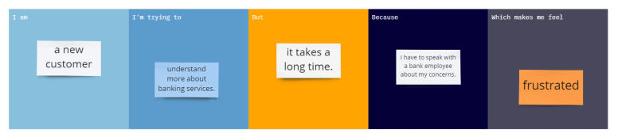

**Problem statement 2:**

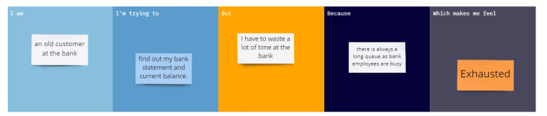

**Problem statement 3:**

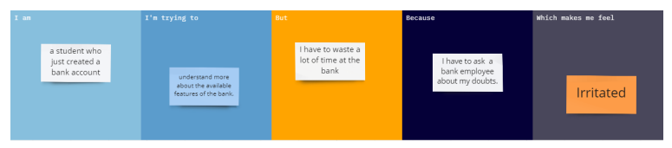

**3.IDEATION AND PROPOSED SOLUTION**

**3.1 EMPATHY MAP CANVAS:**

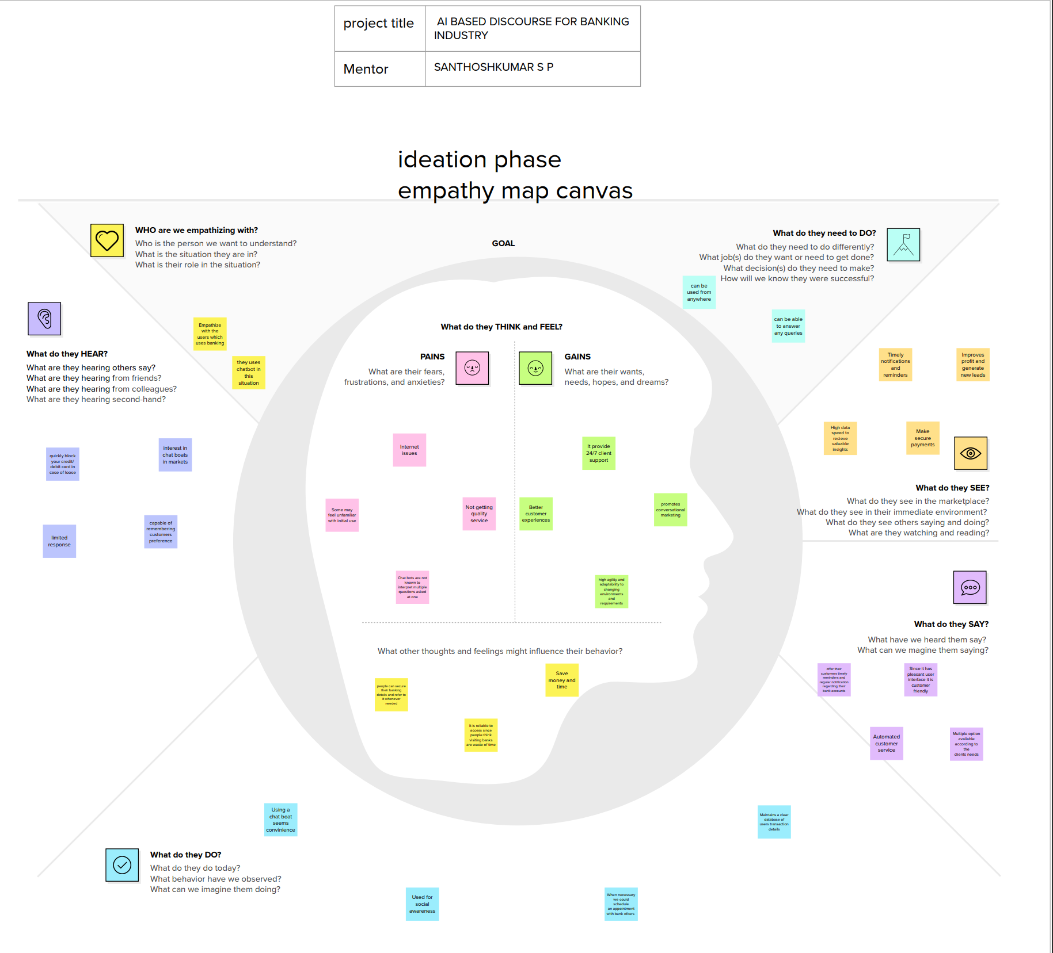

**3.2 BRAINSTORMING**

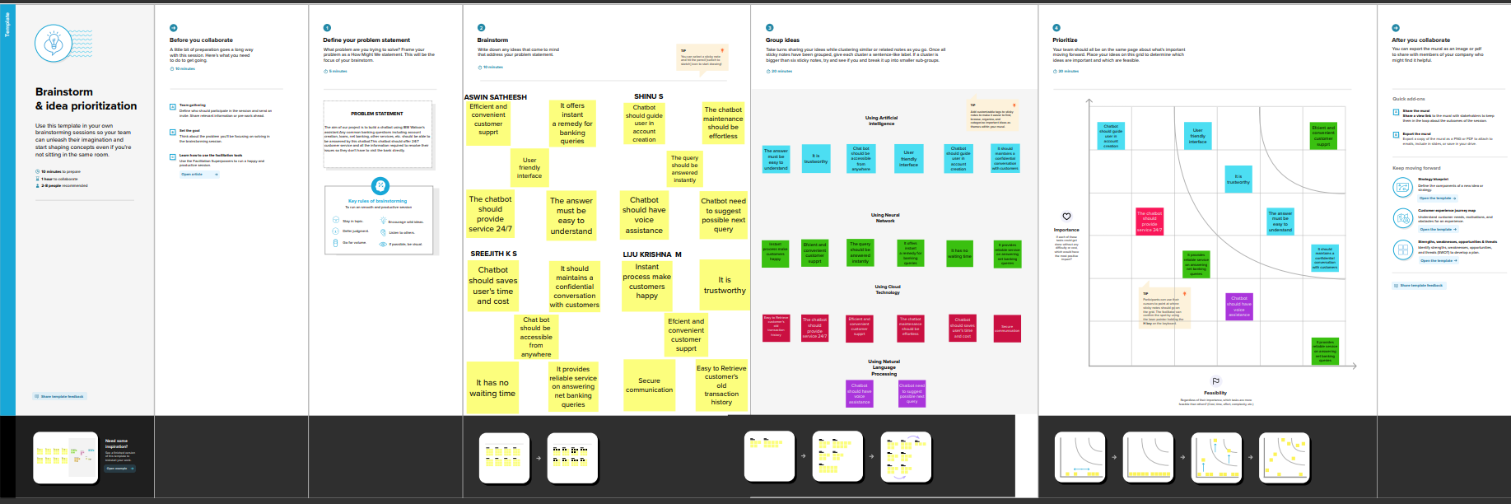

**3.3 PROPOSED SOLUTION**

|  |  |  |
| --- | --- | --- |
| **SL NO** | **PARAMETER** | **DESCRIPTION** |
| **1** | Problem Statement (Problem to be solved) | The aim of our project is to build a chatbot using IBM watson’s assistant . Any common banking questions including account creation loans, net banking, other services etc.should be able to answered by this chatbot .  This chatbot should offer 24/7 customer service and all the information required to resolve their issues so they don’t have to visit the bank directly. |
| **2** | Idea / Solution description | To give customers the best choice, an intelligent system must be put in place to guide them through all of the financial services the bank provides |
| **3** | Novelty / Uniqueness | AI-powered chatbots should be able to respond to any general banking questions including opening an account, loans, net banking, other services, etc.  It quickly and effectively responds to client questions in a way that is economical. |
| **4** | Social Impact / Customer Satisfaction | People are at ease using our Bot because They can communicate by speaking in their own language. It can end prolonged wait periods. Clients feel as they are able to do transactions wherever and whenever. Our AI chatbot enables Clients to carry out their entire process immediately As a result, it helps customers save time. |
| **5** | Business Model (Revenue Model) | Business Plan (Revenue Model) Banks will find it more affordable to use chatbots to respond to customer questions. It eliminates the need for a huge customer care workforce and even reduces the workload of bank employees, allowing them to put more of their energy into other projects |
| **6** | Scalability of the Solution | Companies can easily outgrow their planning strategies in light of more facts volume of users, number of users, or complexity in design models. This development may Our chatbots manage it as they grow into several economic sectors, without affecting effectiveness.  Our chatbot can be expanded .given that it is dynamic and deep learning trained studying models.  The greatest benefit of our chatbot is its ability to enterprises to easily scale up and expand particularly as web traffic grows |

**3.4 PROBLEM SOLUTION FIT:**

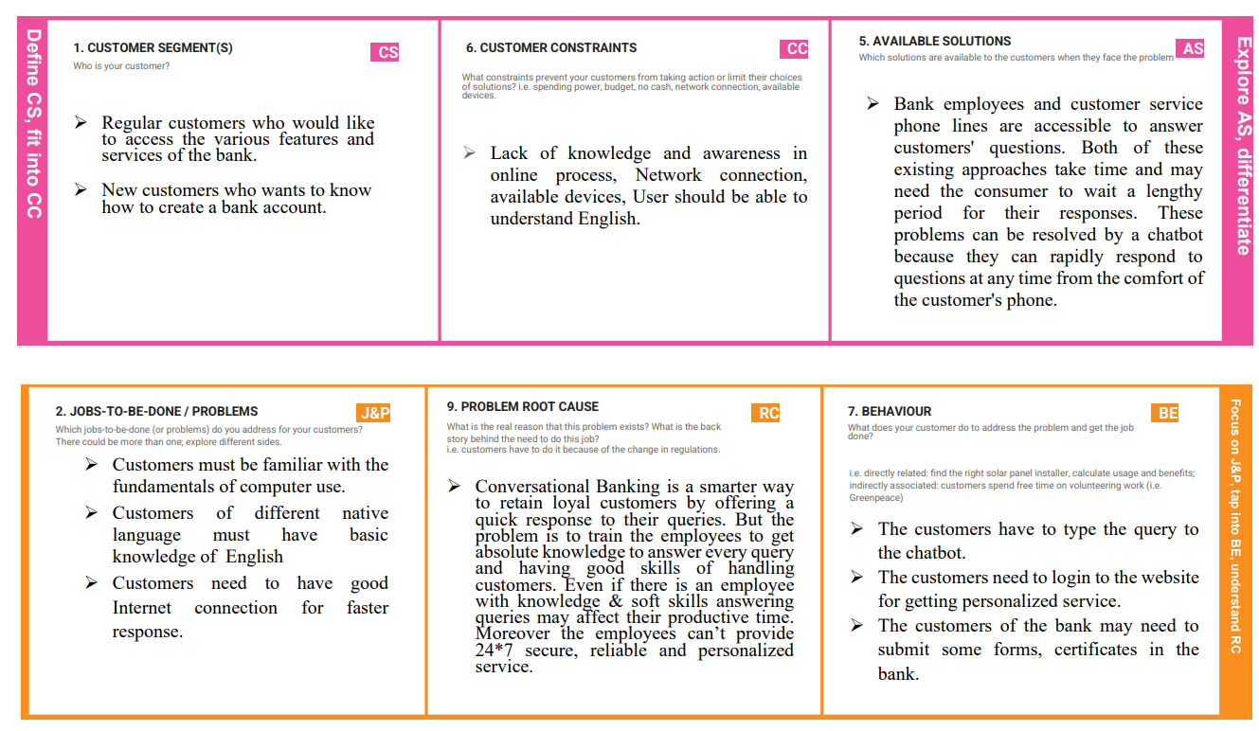

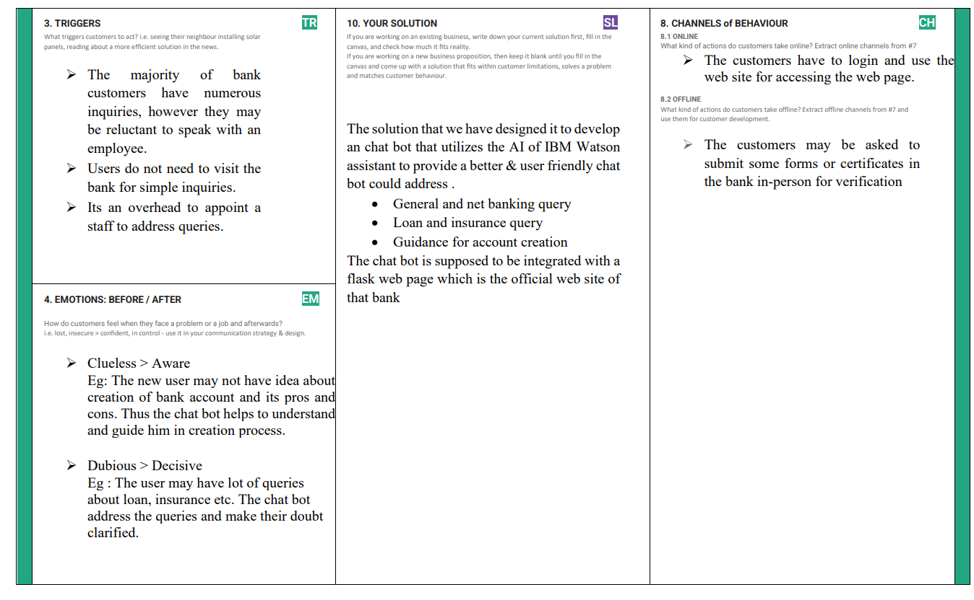

**4.REQUIREMENT ANALYSIS**

**4.1 FUNCTIONAL REQUIREMENTS**

Following are the functional requirements of the proposed solution.

|  |  |  |
| --- | --- | --- |
| **FR No.** | **Functional Requirement (Epic)** | **Sub Requirement (Story / Sub-Task)** |
| FR-1 | User Registration | Registration through Form Registration through Gmail Registration through LinkedIn |
| FR-2 | User Confirmation | Confirmation via Email Confirmation via OTP |
| FR-3 | User Login | Login through valid id and password |
| FR-4 | General Query | The chatbot should be able to respond to questions about the hours when banks are open, the currency conversion  policy, storage lockers, a branch locator, a list of available branches, CIBIL, etc. |
| FR-5 | Updates | The client can simply become familiar with the new services and policies by viewing the latest updates on the Virtual Assistant. |
| FR-6 | Banking credentials | User can manage their account credentials |

# 4.2 NON-FUNCTIONAL REQUIREMENTS:

Following are the non-functional requirements of the proposed solution.

|  |  |  |
| --- | --- | --- |
| **FR No.** | **Non-Functional Requirement** | **Description** |
| NFR-1 | **Usability** | AI-powered chatbots should be able to respond to any general banking questions including opening an account, loans, net banking, other services, etc. It provides prompt, efficient, and cost-effective answers  to consumers' questions. |
| NFR-2 | **Security** | Customer conversations with the AI Chatbot are kept private. Between the user and the bank, a chatbot will offer personalized and effective communication. |
| NFR-3 | **Reliability** | The best possible service is swiftly provided by chatbots that have been expertly trained using AI to offer answers to the most popular and often requested questions. AI Chatbots offer a reliable  trustworthy user experience as a result. |
| NFR-4 | **Performance** | The speed of the chatbot has to be faster than the time it would take a human to compose the reply. The chatbot should be connected to a knowledge-based  database and set up to retrieve data quickly. |
| NFR-5 | **Availability** | AI chatbots are available 24/7 service to answer all consumer questions and walk them through the entire banking procedure. Anyone with minimal hardware  and internet access can access it. |
| NFR-6 | **Scalability** | AI chatbots are assisting the banking sector in both scaling their customer care and raising client satisfaction levels at the same time. It can be  scaled as per the requirements of the bank to include answers to queries related to any new feature or service introduced by the bank. |

**5.PROJECT DESIGN**

**5.1 DATA FLOW DIAGRAM AND USER STORIES:**

**USER QUERY**

**IBM CLOUD**

**BOT PREVIEW**

**RESPONSE**

**IBM WATSON’S ASSISTANT**

**User Stories**

| **User Type** | **Functional Requirement (Epic)** | **User Story Number** | **User Story / Task** | **Acceptance criteria** | **Priority** | **Release** |
| --- | --- | --- | --- | --- | --- | --- |
| Customer (Mobile/web user) | Bot Preview | USN-1 | As a user, I can see a chatbot preview where I can write questions in a message box to ask questions. | I can access the chatbot’s message box | High | Sprint-1 |
|  |  | USN-2 | As a user, I can view the frequently asked questions (FAQ). | Access to the Frequently Asked Questions is provided to me (FAQ). | High | Sprint-1 |
|  | Updates | USN-3 | As a user, I can see the updates and search for further information about them | I can able to view and access the updates | Medium | Sprint-2 |
| Administrator | Edit options | USN-4 | As a user, I can add/edit welcome messages and FAQs to the Bot | I can access to add options like greeting messages, etc | High | Sprint-1 |
|  |  | USN-5 | As an admin, I have the authority to provide ideas and alternatives to the Bot. | can deliver ideas and alternatives | Medium | Sprint-2 |
|  |  | USN-6 | As an admin, I can make a post regarding new updates. | I can post new updates. | Medium | Sprint-2 |
| Developer | Support | USN-7 | I can easily construct a bank bot as a developer using IBM Watson Assistant. | can easily accessible Watson Assistant. | High | Sprint-1 |
|  | Upcoming Features | USN-8 | I can add new features to the Bot as a developer. | can able to perform new features to the bot | Medium | Sprint-2 |
|  | Design | USN-9 | As a developer, I can create as well as design the chatbot’s UI. | I can design the chatbot’s UI. | High | Sprint-1 |

**5.2 TECHNICAL ARCHITECTURE**

|  |  |  |
| --- | --- | --- |
| **USER** | CUSTOMER | |
| **INTERFACE** | **DEVICES**  Browser | |
| **IBM Cloud** | **Pre Processing**  **Natural programming language** | |
| **Watson assistant** | |
|  |  |

|  |  |
| --- | --- |
|  | **Post Processing**  **search skills Dialogue Skills** |
| **Backend System** | **File Repository IBM DB2 warehouse IBM Cloud functions** |

**Table-1 : Components & Technologies:**

|  |  |  |  |
| --- | --- | --- | --- |
| S.No | Component | Description | Technology |
| 1. | User Interface | The programme is used by a user. for instance, a chatbot or a web user interface. | HTML, CSS,  JavaScript / Angular Js / React Js etc. |
| 2. | Application Logic-1 | processing of user messages | NLP and NLU |
| 3. | Application Logic-2 | Matching intent / Entities | IBM Watson Assistant |
| 4. | Application Logic-3 | Building a Deep Learning Model via Training | IBM Watson Studio |
| 5. | Application Logic-4 | Deployment | Python Flask |
| 6. | Database | Type of Data: Dialog, Intent, etc. The  model data and message statistics for the stored and configured. | MySQL, NoSQL, etc. |

|  |  |  |  |
| --- | --- | --- | --- |
| 7. | Cloud Database | Database Service on Cloud | IBM DB2, IBM  Cloudant etc. |
| 8. | File Storage | To store datasets | IBM Block Storage or Other Storage Service or Local Filesystem |
| 9. | External API- 1 | Type of Data: Dialog, Intent, etc. The trained model data and message statistics for the user are stored and configured. | IBM Watson Assistant API, etc. |
| 10. | External API-2 | Banking API - Access to data and data transmission across systems. | Banking API, etc. |
| 11. | Machine Learning Model | Models of deep learning for intent detection and other tasks | Object Recognition Model, etc. |
| 12. | Infrastructure (Server / Cloud) | Local Server Configuration for Application Deployment on Local and Cloud Systems: Python Flask Configuration of the cloud server: Cloud  Foundry | Python Flask, Cloud Foundry, Kubernetes, etc. |

**Table-2: Application Characteristics:**

|  |  |  |  |
| --- | --- | --- | --- |
| S.No | Characteristics | Description | Technology |
| 1. | Open-Source Frameworks | Open-source frameworks used is Python Flask | Technology used Python Flask |
| 2. | Security Implementations | data encryption that is end-to-end, separation of client information, scanning for vulnerabilities and detecting intrusions protection from malware and viruses, user device security, installing security updates. | SHA-256, Encryptions, IAM Controls, OWASP,IBM Watson Assistant etc. |

|  |  |  |  |
| --- | --- | --- | --- |
| 3. | Scalable Architecture | The four pillars of chatbot architecture are as follows. They include scripts, entities, data flow, and intentions (3 – tierarchitecture  –presentation tier, application tier, data tier and Microservices  architecture) | Technology used – IBM Watson Assistant |
| 4. | Availability | Utilizing load balancers, various servers, etc., the Bot is made accessible. | Technology used –IBM Watson Assistant |
| 5. | Performance | Automation using IBM Watson IBM Watson studio is used to train the deep learning model for improved performance. | Technology used – IBM Watson Assistant |

**6.PROJECT PLANNING AND SCHEDULING**

**Product Backlog, Sprint Schedule, and Estimation**

|  |  |  |  |  |  |  |
| --- | --- | --- | --- | --- | --- | --- |
| **Sprint** | **Functional Requirement (Epic)** | **User**  **Story**  **Number** | **User Story / Task** | **Story Points** | **Priority** | **Team Members** |
| Sprint-1 | Create IBM Service | USN-1 | As a user, I can see a Watson Assistant. | 1 | High | Aswin  Satheesh,  Shinu s |
| Sprint-1 | Chatbot Skills Creation | USN-2 | As a user, I will see the Chatbot having banking-related skills. | 1 | High | Sreejith ks, liju krishna |
| Sprint-2 | Creating Saving Account Action | USN-3 | As a user, I can converse with the chatbot regarding saving account-related queries. | 2 | Medium | Aswin  Satheesh,  Shinu s |
| Sprint-2 | Creating Current Account Action | USN-4 | As a user, I can converse with the chatbot regarding current account-related queries. | 2 | Medium | Liju krishna, Aswin satheesh |
| Sprint-3 | Creating Loan Account Action | USN-5 | As a user, I can converse with the chatbot regarding loan account-related queries. | 2 | High | Aswin  Satheesh,  Shinu s |

|  |  |  |  |  |  |  |
| --- | --- | --- | --- | --- | --- | --- |
| **Sprint** | **Functional Requirement (Epic)** | **User**  **Story**  **Number** | **User Story / Task** | **Story Points** | **Priority** | **Team Members** |
| Sprint-3 | Creating General Query Action | USN-6 | As a user, I can converse with the chatbot regarding general queries. | 2 | Medium | Sreejith ks, liju krishna |
| Sprint-3 | Creating Net Banking Action | USN-7 | As a user, I can converse with the chatbot regarding net banking-related queries. | 2 | High | Aswin  Satheesh,  Shinu s |
| Sprint-4 | Creating Assistant & Integrate  With Flask Web Page (Build  Python Code) | USN-8 | As a user, I can see a flask web page for bank. | 1 | Low | Sreejith ks, liju krishna |
| Sprint-4 | Build HTML Code | USN-9 | As a user, I can web pages integrated with a chatbot. | 1 | Medium | Shinu s,liju krishna |
| Sprint-4 | Run The Application | USN-10 | As a user, I can communicate with the chatbot 24*7. | 1 | Low | Aswin Satheesh, sreejith ks |

|  |  |  |  |  |  |  |
| --- | --- | --- | --- | --- | --- | --- |
| **Sprint** | **Total Story Points** | **Duration** | **Sprint Start Date** | **Sprint End Date (Planned)** | **Story Points**  **Completed (as on**  **Planned End Date)** | **Sprint Release Date (Actual)** |
| Sprint-1 | 20 | 6 Days | 8 Nov 2022 | 14 Nov 2022 | 20 | 14 Nov 2022 |
| Sprint-2 | 20 | 6 Days | 8 Nov 2022 | 14 Nov 2022 | 20 | 14 Nov 2022 |
| Sprint-3 | 20 | 6 Days | 8 Nov 2022 | 14 Nov 2022 | 20 | 14 Nov 2022 |
| Sprint-4 | 20 | 6 Days | 10 Nov2022 | 16 Nov 2022 | 20 | 16 Nov 2022 |
|  |  |  |  |  |  |  |
|  |  |  |  |  |  |  |
|  |  |  |  |  |  |  |
|  |  |  |  |  |  |  |

**Project Tracker, Velocity & Burndown Chart:**

**Velocity:**

Imagine we have a 10-day sprint duration, and the velocity of the team is 20 (points per sprint). Let’s calculate the team’s average velocity (AV) per iteration unit (story points per day)



# AV=20/2=10

**AV=10**

**Burndown Chart:**

A burn down chart is a graphical representation of work left to do versus time. It is often used in agile [software development m](https://www.visual-paradigm.com/scrum/what-is-agile-software-development/)ethodologies such as [Scrum.](https://www.visual-paradigm.com/scrum/scrum-in-3-minutes/) However, burn down charts can be applied to any project containing measurable progress over time.

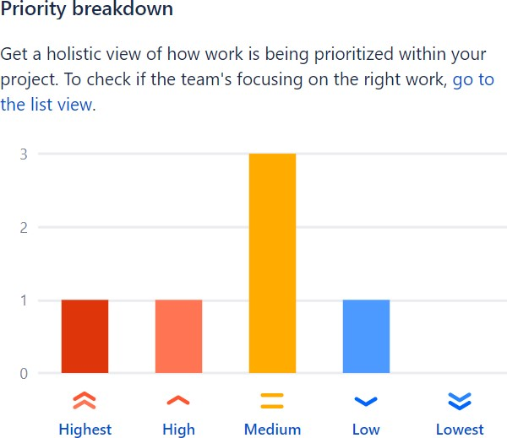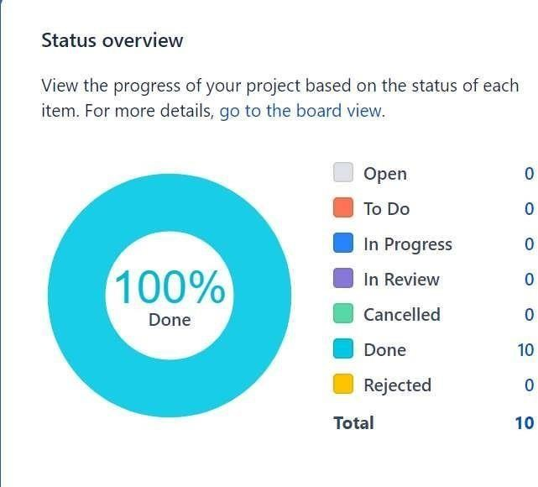

**6.3 REPORTS FROM JIRA:**

JIRA offers reporting in a number of different formats. Project reports that are available from the home screen of the selected project, Gadgets that can be added and arranged in Dashboards and for each filter, the issue navigator offers various output formats that can be used in third party reporting software. Additionally, we will mention some advanced methods that customers have been using.

**Standard Reports :**

In JIRA, a project will automatically offer standard reports available to the user without any necessary configuration. These standard reports comprise a wide range of reporting applications such as time tracking, workload and also abstract reports like Pie Charts that can be used in various ways.

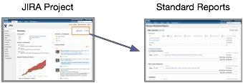

**7. CODING AND SOLUTION**

**Templates folder:**

**chatbot.html**

<html>

<head>

<script>

window.watsonAssistantChatOptions = {

integrationID: "9a06101e-24c2-4244-b6fa-562956328dbc", // The ID of this integration.

region: "us-south", // The region your integration is hosted in.

serviceInstanceID: "ee42311a-a61a-4c3e-8cfa-160a4fc13607", // The ID of your service instance.

onLoad: function(instance) {

instance.render();

}

};

setTimeout(function() {

const t = document.createElement('script');

t.src = "https://web-chat.global.assistant.watson.appdomain.cloud/versions/" + (window.watsonAssistantChatOptions.clientVersion || 'latest') + "/WatsonAssistantChatEntry.js";

document.head.appendChild(t);

});

</script>

<base href="/">

<title>Banking Services</title>

<meta charset="utf-8">

<meta name="viewport" content="width=device-width, initial-scale=1">

<meta http-equiv="X-UA-Compatible" content="IE=edge">

<meta property="og:image" content="conversation.svg" />

<meta property="og:title" content="Conversation Chat Simple" />

<meta property="og:description" content="Sample application that shows how to use the Conversation API to identify user intents" />

<link rel="shortcut icon" href="favicon.ico" type="image/x-icon">

<link rel="stylesheet" href="https://maxcdn.bootstrapcdn.com/bootstrap/4.0.0/css/bootstrap.min.css" integrity="sha384-Gn5384xqQ1aoWXA+058RXPxPg6fy4IWvTNh0E263XmFcJlSAwiGgFAW/dAiS6JXm" crossorigin="anonymous">

<link rel="stylesheet" href="css/app.css">

<style type="text/css">

body {

padding-top: 3.5rem;

}

</style>

</head>

<body>

<nav class="navbar navbar-expand-md navbar-dark fixed-top bg-dark">

<a class="navbar-brand" href="#">Banking Services</a>

<button class="navbar-toggler" type="button" data-toggle="collapse" data-target="#navbarsExampleDefault" aria-controls="navbarsExampleDefault" aria-expanded="false" aria-label="Toggle navigation">

<span class="navbar-toggler-icon"></span>

</button>

<div class="collapse navbar-collapse" id="navbarsExampleDefault">

<ul class="navbar-nav mr-auto">

<li class="nav-item active">

<a class="nav-link" href="#">Home <span class="sr-only">(current)</span></a>

</li>

<li class="nav-item">

<a class="nav-link" href="#">About Us</a>

</li>

<li class="nav-item dropdown">

<a class="nav-link dropdown-toggle" href="#" id="dropdown01" data-toggle="dropdown" aria-haspopup="true" aria-expanded="false">Services</a>

<div class="dropdown-menu" aria-labelledby="dropdown01">

<a class="dropdown-item" href="#">Banking</a>

<a class="dropdown-item" href="#">Investment</a>

<a class="dropdown-item" href="#">Home Loan</a>

</div>

</li>

</ul>

<form class="form-inline my-2 my-lg-0">

<input class="form-control mr-sm-2" type="text" placeholder="Search" aria-label="Search">

<button class="btn btn-outline-success my-2 my-sm-0" type="submit">Search</button>

</form>

<ul class="navbar-nav navbar-right">

<li class="nav-item">

<a class="nav-link" href="#">Login</a>

</li>

<li class="nav-item">

<a class="nav-link" href="#">Register</a>

</li>

</ul>

</div>

</nav>

<main role="main">

<!-- Main jumbotron for a primary marketing message or call to action -->

<div class="jumbotron">

<div class="container" style="background-image: url('img_girl.jpg');">

<h1 class="display-3">Welcome to Banking services</h1>

<p>We provide extensive services from retail banking, investment, home loan, auto loan and many more</p>

<p><a class="btn btn-primary btn-lg" href="#" role="button">Learn more &raquo;</a></p>

</div>

</div>

<div class="container">

<!-- Example row of columns -->

<div class="row">

<div class="col-md-4">

<h2>Banking</h2>

<p>Banking services provide retail and online banking. It offers all kinds of accounts from checking, saving, and bussiness accounts

</p>

<p><a class="btn btn-secondary" href="#" role="button">View details &raquo;</a></p>

</div>

<div class="col-md-4">

<h2>Investment</h2>

<p>Banking services also provides investment opportunity to clients. It has huge basket of various stocks and bonds. </p>

<p><a class="btn btn-secondary" href="#" role="button">View details &raquo;</a></p>

</div>

<div class="col-md-4">

<h2>Loan</h2>

<p>Banking services also helps you find loan for personal, home and auto. We provide best rate and beat the rate thats out in the market.</p>

<p><a class="btn btn-secondary" href="loan.html" role="button">View details &raquo;</a></p>

</div>

</div>

<hr>

</div>

<!-- /container -->

</main>

<footer class="container">

<p>&copy; Banking services 2022</p>

</footer>

<div id="contentParent" class="responsive-columns-wrapper">

<div id="chat-column-holder" class="responsive-column content-column">

<div class="chat-column">

<div id="scrollingChat">

<br>

<h4>Welcome to Banking Services.</h4>

</div>

<label for="textInput" class="inputOutline">

<input id="textInput" class="input responsive-column" class="form-control form-control-lg" placeholder="Type something" type="text"

onkeydown="/*globals CanvasJS */

ConversationPanel.inputKeyDown(event, this)">

</label>

</div>

</div>

</div>

<!-- Bootstrap core JavaScript

================================================

-->

<!-- Placed at the end of the document so the pages load faster -->

<script src="https://code.jquery.com/jquery-3.2.1.slim.min.js" integrity="sha384-KJ3o2DKtIkvYIK3UENzmM7KCkRr/rE9/Qpg6aAZGJwFDMVNA/GpGFF93hXpG5KkN" crossorigin="anonymous"></script>

<script src="https://cdnjs.cloudflare.com/ajax/libs/popper.js/1.12.9/umd/popper.min.js" integrity="sha384-ApNbgh9B+Y1QKtv3Rn7W3mgPxhU9K/ScQsAP7hUibX39j7fakFPskvXusvfa0b4Q" crossorigin="anonymous"></script>

<script src="https://maxcdn.bootstrapcdn.com/bootstrap/4.0.0/js/bootstrap.min.js" integrity="sha384-JZR6Spejh4U02d8jOt6vLEHfe/JQGiRRSQQxSfFWpi1MquVdAyjUar5+76PVCmYl" crossorigin="anonymous"></script>

<script src="js/modal.js"></script>

<script src="js/api.js"></script>

<script src="js/common.js"></script>

<script src="js/conversation.js"></script>

<script src="js/global.js"></script>

</body>

</html>

**Python file:**

**app.py**

from flask import Flask, render_template

app = Flask(__name__)

@app.route('/')

def bot():

return render_template('chatbot.html')

if __name__ == '__main__':

app.run(debug = True)

**7.1) Feature 1**

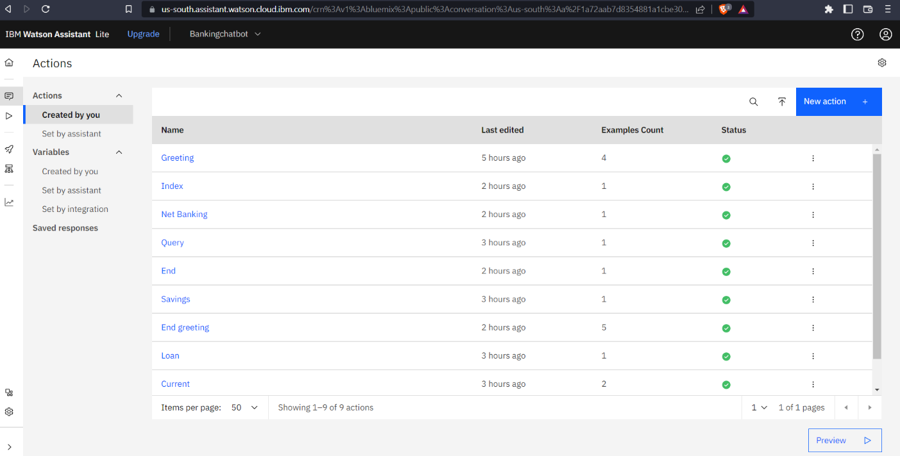

**7.2) Feature 2**

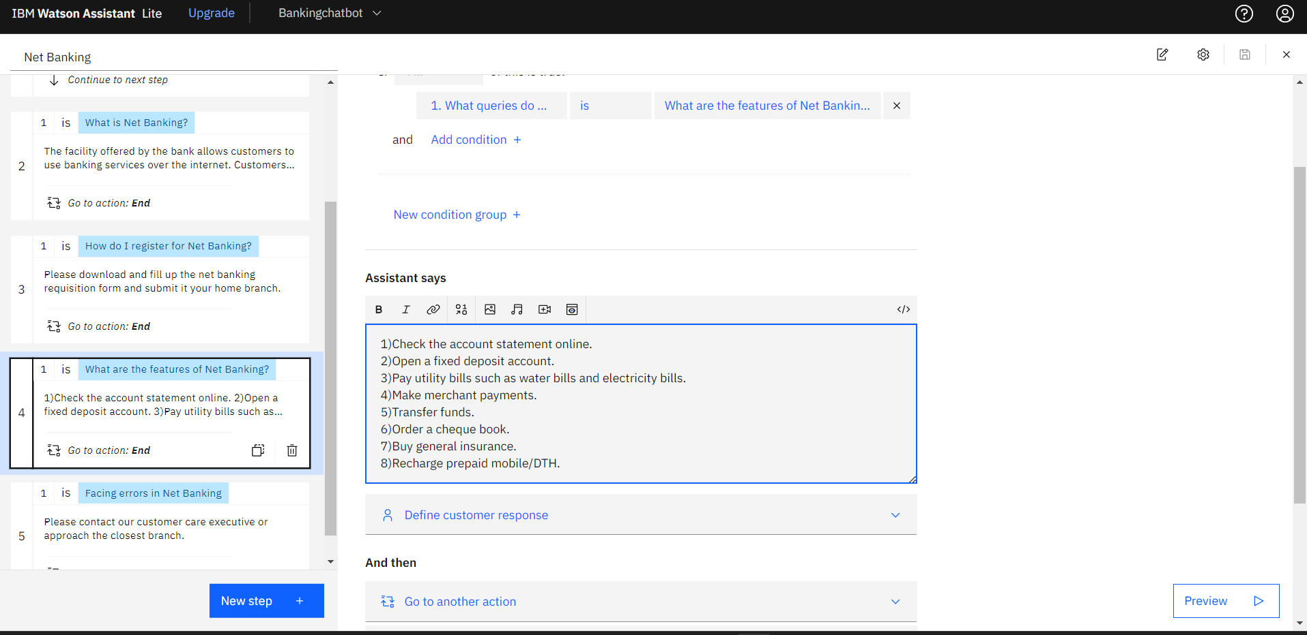

**8.TESTING**

**8.1** Test Cases:

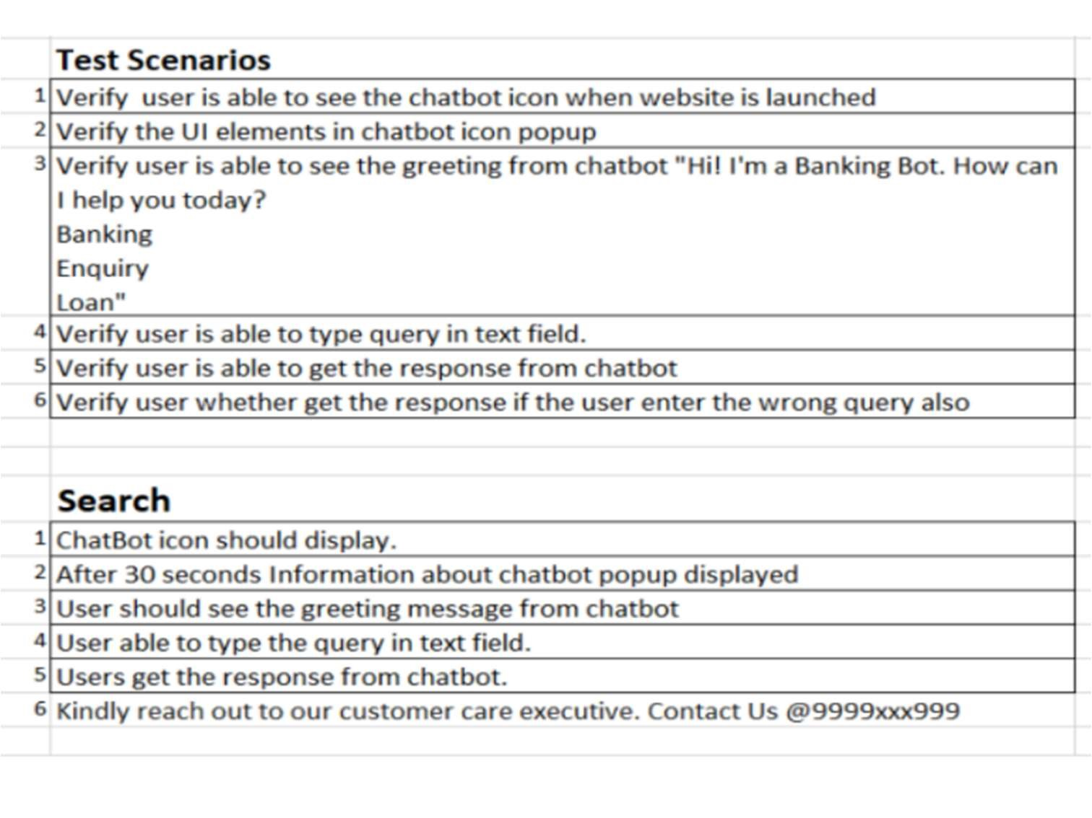

**8.2 User Acceptance Testing**

**UAT Execution & Report Submission**

**a) Purpose of Document**

The purpose of this document is to briefly explain the test coverage and open issues of the AI-based discourse for Banking Industry project at the time of the release to User Acceptance Testing (UAT).

**b) Defect Analysis**

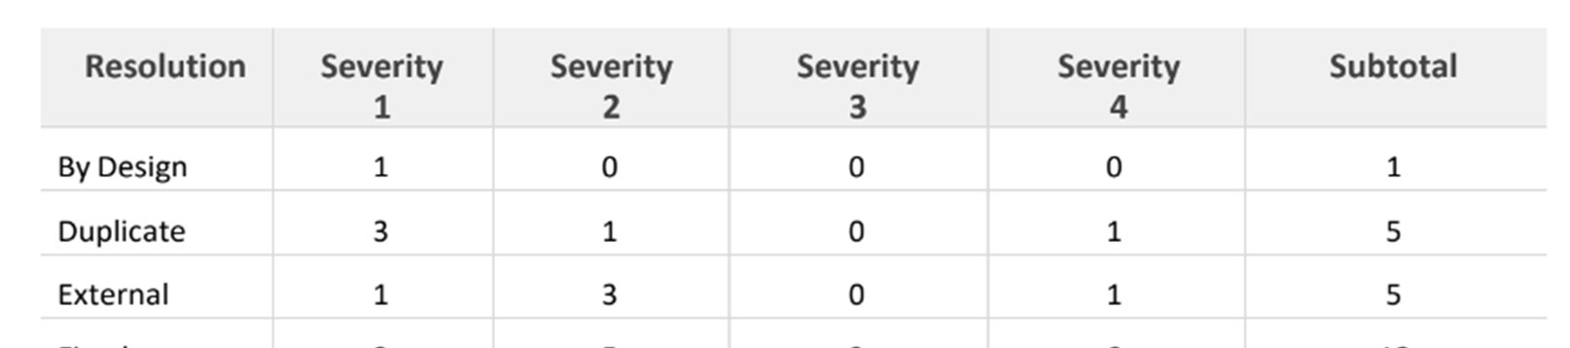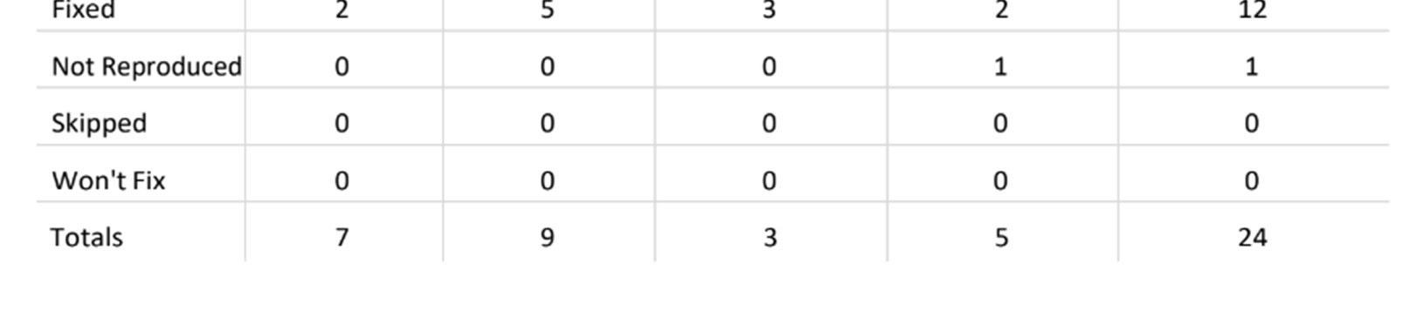

**C) Test Case Analysis**

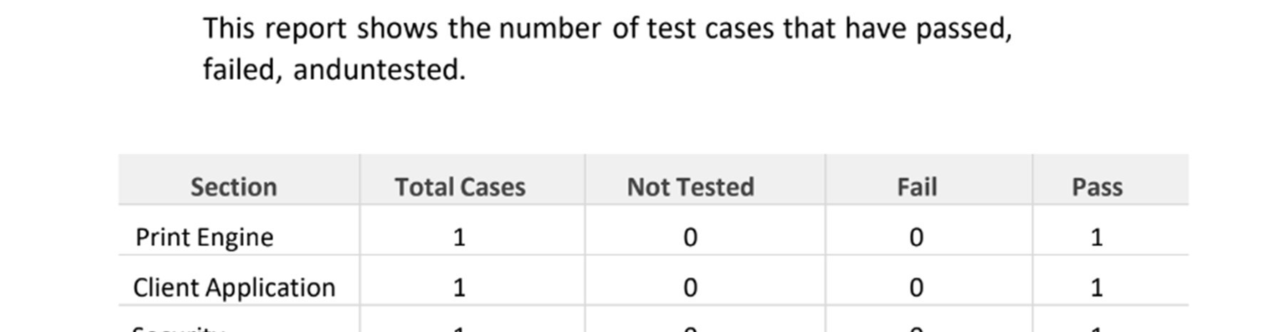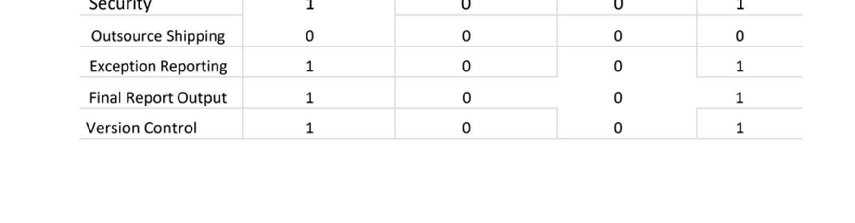

**9) RESULTS**

**9.1)**

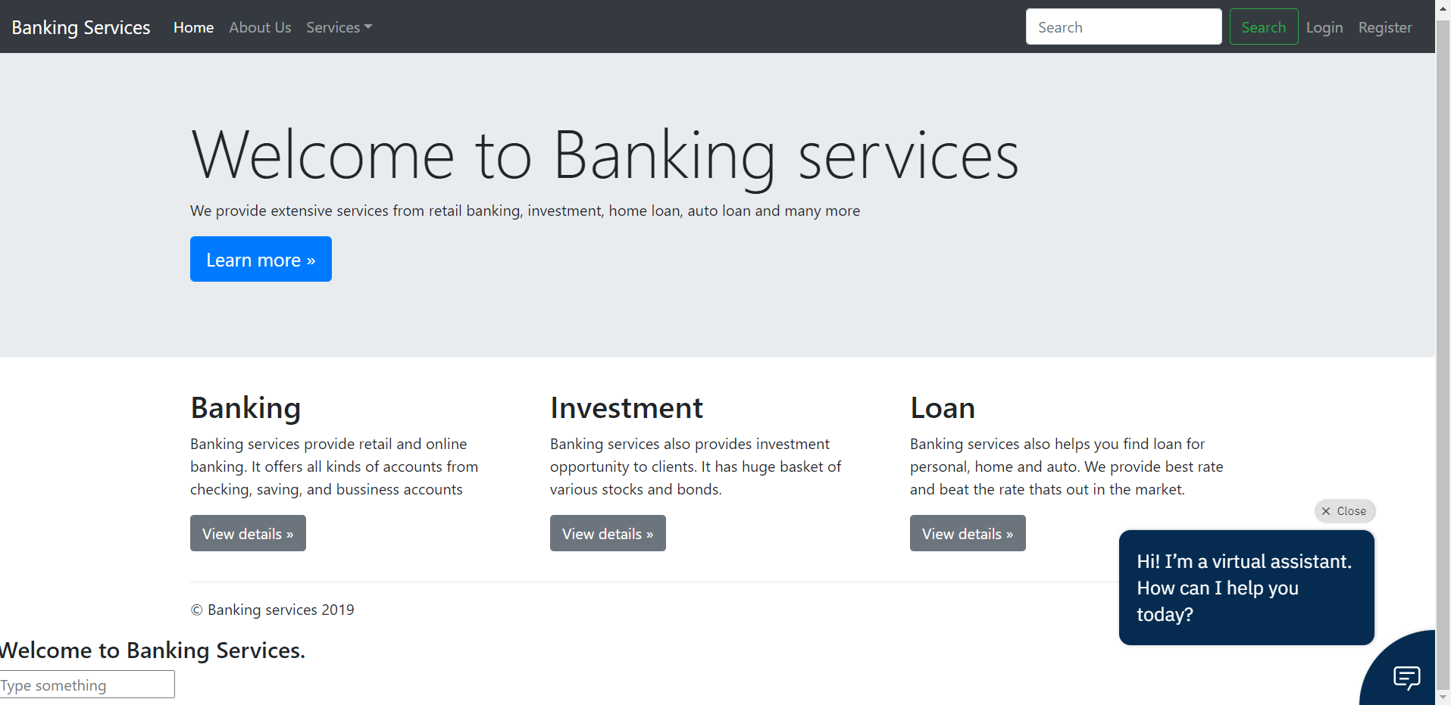

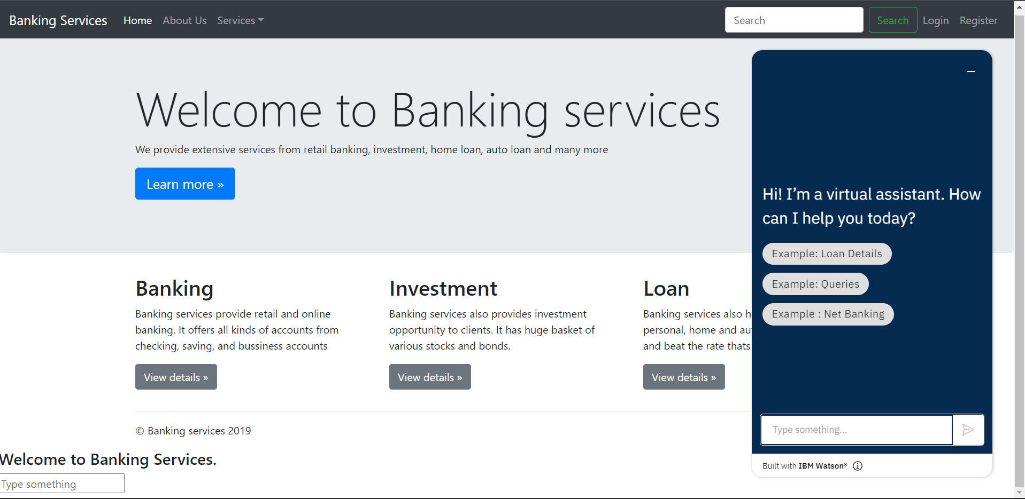

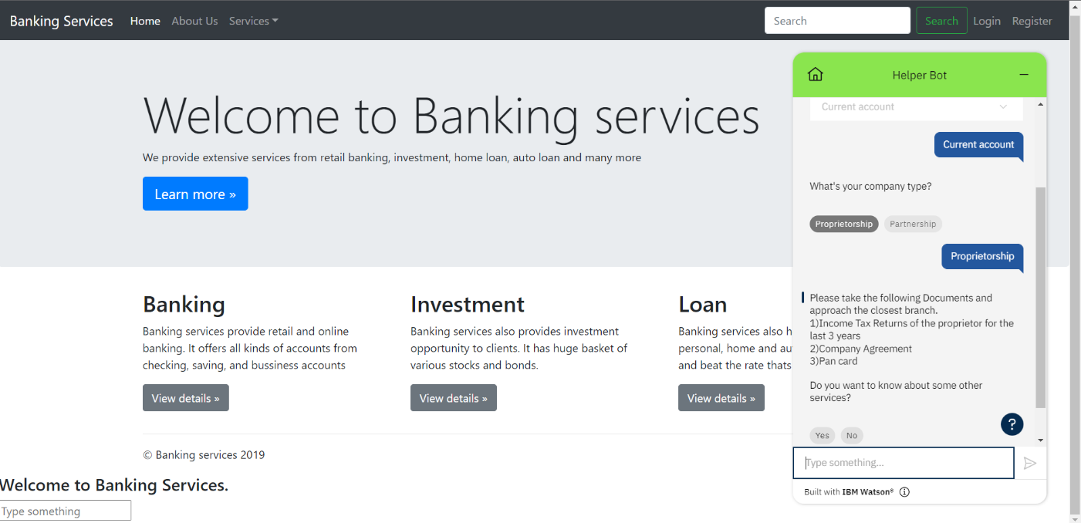

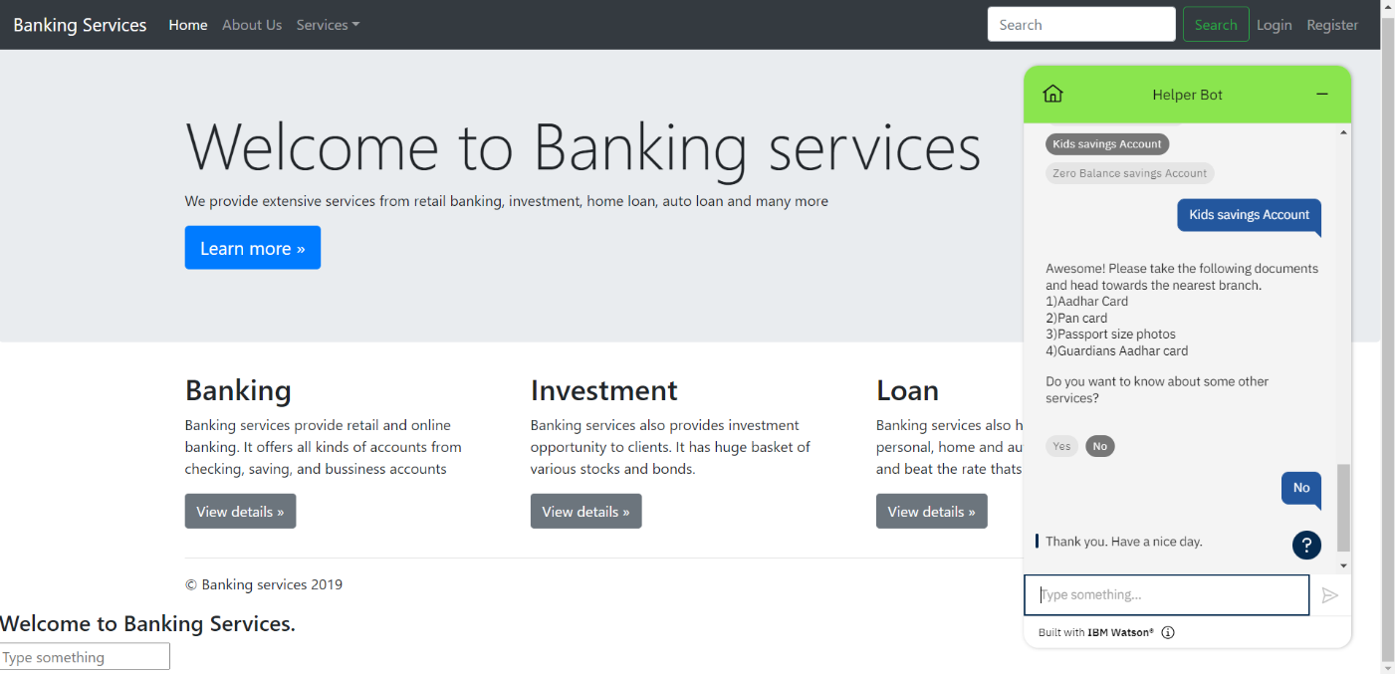

**10. ADVANTAGES AND DISADVANTAGES**

**ADVANTAGES**

1. Chatbots have 24/7 Availability: Chatbots can be available to solve customer problems 24/7 whether it is day or night! They don’t need to sleep after all! This is much more difficult to achieve using human customer service as it would require rotating teams that would be more complicated to manage as well.
2. Chatbots can gather Customer Insights: Companies thrive on customer data! The more data they have, the better they can cater to their customers and be much more successful. That’s where chatbots can be a big help. Whenever you interact with any chatbots on a company page, you provide basic data such as user preferences, buying habits, sentiments, etc. which can then be analysed to understand market trends, operational risks, etc. And using this information, the company can solver customer issues much easier and create targeted products. This will help in increasing their customer loyalty!

**DISADVANTAGES**

1. Chatbots sound too Mechanical: Chatbots are not human and so obviously they cannot interact as a human with customers. They sound too mechanical and can only give answers to problems that they have been programmed with. They cannot answer a customer according to the context and they cannot show any emotions if needed. Chatbots also cannot maintain a natural-sounding conversation in-depth with customers and that is why they are only useful in solving basic queries. But this can create a disconnect with customers who prefer the human approach when solving their problems.
2. Chatbots can only handle basic Questions: Chatbot are still a basic Artificial Intelligence technology and so they can only answer the basic questions of customers and provide general information that is already available to them. They cannot solve complicated queries or answer out of script questions and companies need to have human customer service employees that can manage these for them. However, this is changing with time and currently, more and more advanced chatbots are entering the market.

# 11. CONCLUSION

# In this paper we have provided a survey of relevant works of literature on the subject, and we have analyzed the state of the art in terms of language models, applications, datasets used, and evaluation frameworks. We have also underlined current challenges and limitations, as well as gaps in the literature. Despite technological advancements, AI chatbots are still unable to simulate human speech. This is due to a faulty approach to dialogue modeling and a lack of domain-specific data with open access. For Information Retrieval chatbots , there is also a lack of a learnt AI model. There is still a gap to be closed in terms of applications between Industry models and current advancements in the sector. Large models necessitate a lot of computing power and a lot of training data. There is no universal framework for evaluating chatbots. Several models depend on human evaluation, yet human evaluation is expensive, time-consuming, difficult to scale, biased, and lacks coherence. A new, reliable automatic evaluation approach should be provided to overcome these restrictions

# 12. FUTURE SCOPE

Chatbots are Now Based on Natural Language Processing(NLP)

The goal is to allow users and Artificial Intelligence to communicate naturally and understand complex requests. This would mean that customer service agents would be able to focus on other tasks while the AI takes care of customers' queries. Chatbots in finance, in the digital banking and healthcare industries might save more than 12 billion USD in a year by 2022. According to several estimates, financial organizations might save 2 trillion USD by 2030 by implementing artificial intelligence and cutting costs by 35%. In the digital banking business, banks with Chatbots can automate a variety of functions in addition to enhancing everyday operations and the universal consumer experience as fund transfer, Notifications & Alerts at the Right Time, Get help from a Customer Service Representative, simple lead generation.

**14.APPENDIX**

**Source Code**

**Templates folder**

<html>

<head>

<script>

window.watsonAssistantChatOptions = {

integrationID: "9a06101e-24c2-4244-b6fa-562956328dbc", // The ID of this integration.

region: "us-south", // The region your integration is hosted in.

serviceInstanceID: "ee42311a-a61a-4c3e-8cfa-160a4fc13607", // The ID of your service instance.

onLoad: function(instance) {

instance.render();

}

};

setTimeout(function() {

const t = document.createElement('script');

t.src = "https://web-chat.global.assistant.watson.appdomain.cloud/versions/" + (window.watsonAssistantChatOptions.clientVersion || 'latest') + "/WatsonAssistantChatEntry.js";

document.head.appendChild(t);

});

</script>

<base href="/">

<title>Banking Services</title>

<meta charset="utf-8">

<meta name="viewport" content="width=device-width, initial-scale=1">

<meta http-equiv="X-UA-Compatible" content="IE=edge">

<meta property="og:image" content="conversation.svg" />

<meta property="og:title" content="Conversation Chat Simple" />

<meta property="og:description" content="Sample application that shows how to use the Conversation API to identify user intents" />

<link rel="shortcut icon" href="favicon.ico" type="image/x-icon">

<link rel="stylesheet" href="https://maxcdn.bootstrapcdn.com/bootstrap/4.0.0/css/bootstrap.min.css" integrity="sha384-Gn5384xqQ1aoWXA+058RXPxPg6fy4IWvTNh0E263XmFcJlSAwiGgFAW/dAiS6JXm" crossorigin="anonymous">

<link rel="stylesheet" href="css/app.css">

<style type="text/css">

body {

padding-top: 3.5rem;

}

</style>

</head>

<body>

<nav class="navbar navbar-expand-md navbar-dark fixed-top bg-dark">

<a class="navbar-brand" href="#">Banking Services</a>

<button class="navbar-toggler" type="button" data-toggle="collapse" data-target="#navbarsExampleDefault" aria-controls="navbarsExampleDefault" aria-expanded="false" aria-label="Toggle navigation">

<span class="navbar-toggler-icon"></span>

</button>

<div class="collapse navbar-collapse" id="navbarsExampleDefault">

<ul class="navbar-nav mr-auto">

<li class="nav-item active">

<a class="nav-link" href="#">Home <span class="sr-only">(current)</span></a>

</li>

<li class="nav-item">

<a class="nav-link" href="#">About Us</a>

</li>

<li class="nav-item dropdown">

<a class="nav-link dropdown-toggle" href="#" id="dropdown01" data-toggle="dropdown" aria-haspopup="true" aria-expanded="false">Services</a>

<div class="dropdown-menu" aria-labelledby="dropdown01">

<a class="dropdown-item" href="#">Banking</a>

<a class="dropdown-item" href="#">Investment</a>

<a class="dropdown-item" href="#">Home Loan</a>

</div>

</li>

</ul>

<form class="form-inline my-2 my-lg-0">

<input class="form-control mr-sm-2" type="text" placeholder="Search" aria-label="Search">

<button class="btn btn-outline-success my-2 my-sm-0" type="submit">Search</button>

</form>

<ul class="navbar-nav navbar-right">

<li class="nav-item">

<a class="nav-link" href="#">Login</a>

</li>

<li class="nav-item">

<a class="nav-link" href="#">Register</a>

</li>

</ul>

</div>

</nav>

<main role="main">

<!-- Main jumbotron for a primary marketing message or call to action -->

<div class="jumbotron">

<div class="container" style="background-image: url('img_girl.jpg');">

<h1 class="display-3">Welcome to Banking services</h1>

<p>We provide extensive services from retail banking, investment, home loan, auto loan and many more</p>

<p><a class="btn btn-primary btn-lg" href="#" role="button">Learn more &raquo;</a></p>

</div>

</div>

<div class="container">

<!-- Example row of columns -->

<div class="row">

<div class="col-md-4">

<h2>Banking</h2>

<p>Banking services provide retail and online banking. It offers all kinds of accounts from checking, saving, and bussiness accounts

</p>

<p><a class="btn btn-secondary" href="#" role="button">View details &raquo;</a></p>

</div>

<div class="col-md-4">

<h2>Investment</h2>

<p>Banking services also provides investment opportunity to clients. It has huge basket of various stocks and bonds. </p>

<p><a class="btn btn-secondary" href="#" role="button">View details &raquo;</a></p>

</div>

<div class="col-md-4">

<h2>Loan</h2>

<p>Banking services also helps you find loan for personal, home and auto. We provide best rate and beat the rate thats out in the market.</p>

<p><a class="btn btn-secondary" href="loan.html" role="button">View details &raquo;</a></p>

</div>

</div>

<hr>

</div>

<!-- /container -->

</main>

<footer class="container">

<p>&copy; Banking services 2022</p>

</footer>

<div id="contentParent" class="responsive-columns-wrapper">

<div id="chat-column-holder" class="responsive-column content-column">

<div class="chat-column">

<div id="scrollingChat">

<br>

<h4>Welcome to Banking Services.</h4>

</div>

<label for="textInput" class="inputOutline">

<input id="textInput" class="input responsive-column" class="form-control form-control-lg" placeholder="Type something" type="text"

onkeydown="/*globals CanvasJS */

ConversationPanel.inputKeyDown(event, this)">

</label>

</div>

</div>

</div>

<!-- Bootstrap core JavaScript

================================================== -->

<!-- Placed at the end of the document so the pages load faster -->

<script src="https://code.jquery.com/jquery-3.2.1.slim.min.js" integrity="sha384-KJ3o2DKtIkvYIK3UENzmM7KCkRr/rE9/Qpg6aAZGJwFDMVNA/GpGFF93hXpG5KkN" crossorigin="anonymous"></script>

<script src="https://cdnjs.cloudflare.com/ajax/libs/popper.js/1.12.9/umd/popper.min.js" integrity="sha384-ApNbgh9B+Y1QKtv3Rn7W3mgPxhU9K/ScQsAP7hUibX39j7fakFPskvXusvfa0b4Q" crossorigin="anonymous"></script>

<script src="https://maxcdn.bootstrapcdn.com/bootstrap/4.0.0/js/bootstrap.min.js" integrity="sha384-JZR6Spejh4U02d8jOt6vLEHfe/JQGiRRSQQxSfFWpi1MquVdAyjUar5+76PVCmYl" crossorigin="anonymous"></script>

<script src="js/modal.js"></script>

<script src="js/api.js"></script>

<script src="js/common.js"></script>

<script src="js/conversation.js"></script>

<script src="js/global.js"></script>

</body>

</html>

**Python file**

**App.py**

from flask import Flask, render_template

app = Flask(__name__)

@app.route('/')

def bot():

return render_template('chatbot.html')

if __name__ == '__main__':

app.run(debug = True)

**GitHub & Project Demo Link :**

**GitHub :** <https://github.com/IBM-EPBL/IBM-Project-48655-1660811038>

**Demo Link :** <https://github.com/IBM-EPBL/IBM-Project-48655-1660811038/blob/master/Final%20Deliverables/demo%20video.mp4>